Rewiring food webs via trophic rewilding

Emilio Berti $\begin{aligned}1,2,∗ \\ {}^{}\end{aligned}$, Scott Jarvie ${}^{1,2}$, and Jens-Christian Svenning ${}^{1,2}$

${}^{1}$ Section for Ecoinformatics and Biodiversity, Department of Bioscience, Aarhus University, Ny Munkegade 114, DK-8000 Aarhus C, Denmark.

${}^{2}$ Center for Biodiversity Dynamics in a Changing World (BIOCHANGE), Department of Bioscience, Aarhus University, Ny Munkegade 114, DK-8000 Aarhus C, Denmark.

corresponding author: emilio.berti@bios.au.dk

Keywords: defaunation, human-driven extinctions, food webs, mammals, rewilding, trophic interactions.

# Abstract

200 words maximum

# Introduction

Humans have degraded ecosystems worldwide, removing from the environment species, their interactions, and the ecological processes associated with them (Ceballos et al., 2015; Dirzo et al., 2014; C. Sandom, Faurby, Sandel, & Svenning, 2014; Valiente-Banuet et al., 2015). Human-driven extirpations of mammals date back to the Late Pleistocene, with a large bodied size-selectivity likely causing extinctions of over half of megafauna genera (122 out of 234 genera >= 44 kg have gone extinct (Barnosky, 2008; Martin, 1984; C. Sandom et al., 2014; F. A. Smith, Smith, Lyons, & Payne, 2018)). As Late Pleistocene mammal extinctions acutely affected large body-sized species, interactions previously maintained by pre-human biodiverse megafauna assemblages have been removed from ecological networks, modifying ecosystem processes and functions (Faurby & Svenning, 2015; Gill, 2014; Malhi et al., 2016). For example, extirpations of apex predators have reduced control of prey densities and generated trophic cascades altering ecosystems structure and dynamics (Atkins et al., 2019; Estes et al., 2011; A. T. Ford et al., 2014; Ripple et al., 2014).

Trophic rewilding, the (re)introduction of large bodied species to restore lost ecological processes and promote self-sustaining biodiverse ecosystems (Svenning et al., 2016), has been proposed to re-establish lost ecological interactions (Perino et al., 2019). For instance, reintroduction of wolves in the Yellowstone National Park have restored the landscape of fear and top-down control effects promoted by large carnivores, re-establishing trophic cascades (Beschta & Ripple, 2016). Rewilding is however not universally accepted, with criticism on both its conceptual and ecological validity (Hayward et al., 2019; Nogués-Bravo, Simberloff, Rahbek, & Sanders, 2016). In fact, data on rewilding are scarce, limited in time, and geographically biased (Tanentzap & Smith, 2018), and community responses to rewilding can be contradictory and inconclusive, arising the issue of when and how to rewild (Alston et al., 2019). Despite evidence for the restoration potential of rewilding is increasing (Perino et al., 2019), there is still poor knowledge of the extent with which rewilding can rewire ecological networks with functionally similar interactions to pre-human conditions at global scale.

Macroecological and biogeographical approaches provide an appropriate framework to assess the potential of rewilding to rewire ecological networks at large scales and deep-time perspectives. These approaches can highlight similarities between extinct and extant species and suggest suitable ecological replacements for rewilding (**reference here?**). Moreover, inference of biotic interactions and reconstruction of prehistoric ecological networks can be used to investigate the consequences of human-driven extinctions and extirpations of large mammals (Marjakangas et al., 2018; Pires et al., 2015; Yeakel et al., 2014). By combining a rewilding scenario supported by paleoecological data with macroecologically-grounded reconstructions of interaction networks it is possible to infer rewilding communities and interactions and examine the potential of rewilding to rewire ecological networks to pre-human conditions (M. M. Pires, 2017).

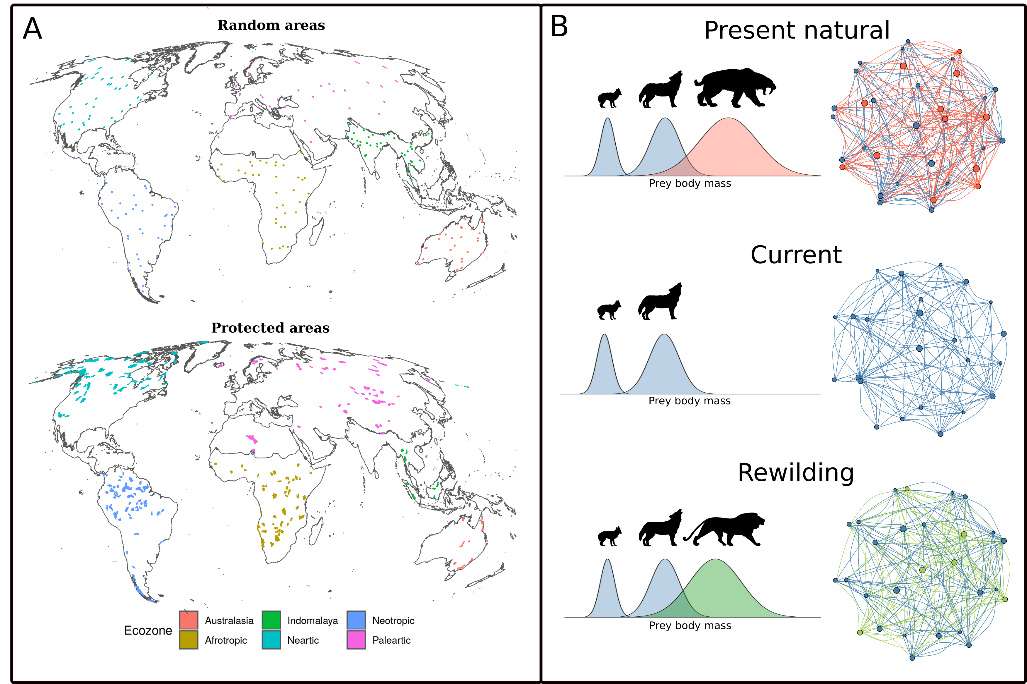

A) areas >= 5,000 km^2 included in the study. B) conceptual representation of the framework used. Dietary niches of species were derived using phylogenetic and trait-based approaches and food webs were inferred using species' diet and geographic distributions under the three scenarios examined. In the network representation of the food webs, species are nodes and predator-prey interactions are edges. Late Pleistocene human-driven extinctions have removed species and trophic interactions (red nodes and edges). Trophic rewilding aims to restore lost interactions by replacing extinct species with suitable ecological analogues (green nodes) that can rewire food webs establishing functionally analogue links (green edges).

In this study, we investigate the potential of rewilding to rewire terrestrial mammal food webs, ecological networks of 'who eats whom', to pre-human conditions in large (>=5,000 km^2) areas worldwide. In particular, we infer food webs under three scenarios: 1) present natural, i.e. a counter-factual scenario where mammals have not been affected by human activities through time (Faurby & Svenning, 2015; Faurby et al., 2018); 2) current conditions; and 3) a rewilding scenario where extant species can re-expand to present-natural ranges and extinct species are replaced by closely related, similarly sized functional analogues that can tolerate similar climates. We then compare food webs under each scenario to investigate whether rewilding can rewire food webs to pre-human states. Specifically, building on the terminology of Genes, Cid, Fernandez, & Pires (2017), we quantify: a) current debt, i.e. how many species and interactions have been lost because of past extinctions; b) rewilding credit, i.e. how many extinct species and interactions can be reintroduced or replaced under the rewilding scenario; and c) rewilding deficit, i.e. how many species and interactions lost because of past extinctions cannot be replaced via rewilding. By comparing debt, credit, and deficit, we assess if rewilding credit can balance current debt.

# Materials and methods

Our workflow is divided into three parts described in detail in the following sections. In summary, we first ran correlative species distribution models (SDMs) to identify climatically suitable habitat for terrestrial mammals. Second, for each extinct species we selected a closely related, similarly sized functional analogue, following conservative criteria. Third, we inferred food webs under present natural, current, and rewilding scenarios and contrasted them to examine if rewilding can restore current defaunated food webs to pre-human conditions. The food web were inferred at sites larger than 5,000 km^2 for both protected areas officially recognized by the International Union for Conservation of Nature (IUCN) and areas randomly scattered across Ecozones. The rationale being to assess the restoration potential of rewilding in areas that are currently more suitable for rewilding initiatives (protected areas), but also to investigate how much food webs can be restored to pre-human conditions in areas that may not be suitable today for rewilding but that can benefit from it in the future (random areas). We ran the analyses for protected and random areas separately; in the following sections we describe the method used for protected areas, implying that the same was done for random areas where applicable.

## Species distribution models

Correlative SDMs are projections in geographic space of species' environmental suitability niches reconstructed through correlation of species' presence with abiotic environmental predictors (Elith & Leathwick, 2009). To overcome biases introduced by anthropogenic pressures on where terrestrial mammals live, we used current and present-natural range maps from the PHYLACINE 1.2 database (Faurby et al., 2018). Following previous descriptions of PHYLACINE (Faurby & Svenning, 2015; Faurby et al., 2018), current ranges were generated from the IUCN range polygon maps for current, natural and reintroduced ranges only (IUCN, 2016). Present-natural ranges are estimates of where species could be today in the complete absence of influence of modern humans (*Homo sapiens*) through time (Faurby & Svenning, 2015). The present natural ranges combine knowledge of a species current IUCN range with species' historic distribution, fossil co-occurrence data, and range modifications caused by humans (Faurby & Svenning, 2015; Faurby et al., 2018). We generated presence locations within combined current and present-natural range maps with a 20 km separation, excluding locations reported above the highest elevation for each species in the IUCN Red List or, if not stated, 4,000 m, which is roughly the 95 percentile for upper elevations of mammals (IUCN, 2016). Elevation was determined for presence locations using the EarthEnv-DEM90 digital elevation model (Robinson, Regetz, & Guralnick, 2014). In total, we identified 4,206 extant terrestrial mammal species with range maps, excluding genus Homo, pinnipeds, and cetaceans.

As environmental predictors for the correlative SDMs, we used four climatic variables from the Worldclim v 2.0 database at 2.5 arc-minute resolution (Fick & Hijmans, 2017) that were reprojected using bilinear interpolation to a 5 km^2 resolution with a Behrmann equal-area projection. The spatially refined variables were maximum temperature of the warmest month (Bio 5), minimum temperature of the coldest month (Bio 6), precipitation of wettest quarter (Bio 16) and precipitation of driest quarter (Bio 17). We selected these variables as they capture extreme conditions and, thus, likely represent factors limiting the distributions of terrestrial mammals. To minimize potential issues with multi-collinearity, we ensured that the variance inflation factor (VIF) among climatic variables was below 4 (O’brien, 2007); VIF values for Bio 5 = 2.69, for Bio 6 = 3.44, for Bio 16 = 1.83, and for Bio 17 = 1.41.

To model the climatic suitability of terrestrial mammals, we fitted maximum entropy (Maxent) models as implemented in the new *maxnet* R-package based on inhomogeneous Poisson processes (S. J. Phillips, Anderson, Dudík, Schapire, & Blair, 2017). Maxent is a presence-background approach, in which environments occupied by a species are contrasted with the available environmental space (Elith et al., 2011; Merow, Smith, & Silander Jr, 2013). We used the default settings of Maxent, besides disabling threshold features to avoid locally overfitted response curves (Merow et al., 2013, 2014) and the use of 100,000 randomly sampled background records – cf. 10,000 that is commonly used – to ensure greater representation of environmental variables available within background areas (Guevara, Gerstner, Kass, & Anderson, 2018). For the background areas, we calculated species-specific buffers around the combined current and present natural ranges to reflect the dispersal abilities of each species, where the maximum distance from the range centroid to the range edge was used (Hof et al., 2018; Poo-Muñoz et al., 2014). Where a species had a disjunct range, the buffer area was calculated from the largest continuous range following (Hof et al., 2018); see figure S# for an example. We only modeled species that had at least 10 presence locations, thus excluding 74 rare island endemics and 2 shrew species with small distribution ranges (*Crocidura allex* and *Crocidura xantippe*). In total, we modeled 4,130 of the 4,206 living terrestrial mammals.

We assessed the predictive performance of Maxent models through five-fold cross validation, by calculating the average continuous Boyce index (CBI; Hirzel, Le Lay, Helfer, Randin, & Guisan (2006)), which indicates how much models discriminate against random expectation, and the average Area Under the Receiver Operating Curve (AUC; Swets (1988)), which indicates how well models differentiate between presences and pseudo-absences regardless of the degree of difference between them. Model fit was inspected by the average omission rate based on the minimum training presence value (ORMTP). CBI values range between -1 and 1, where values > 0 indicate the model's output is positively correlated with the true probability of presence and values < 0 indicate it is negatively correlated with the true probability of presence; AUC values range from <= 0.5 for models with discrimination no better than random to 1 for models with perfect discrimination between occupied and unoccupied places (Fielding & Bell, 1997); and ORMTP values range from 0 for models that are not overfit to 1 for models that are overfit. To convert continuous suitability predictions to binary layers indicating suitable/unsuitable habitat, we used as threshold the suitability value that maximized sensitivity and specificity (MSS) as suggested by Liu, Newell, & White (2016). We further assessed the performance of Maxent models by comparing projections of climatic suitability with 136 introduced range maps from Lundgren, Ramp, Ripple, & Wallach (2018) (n = 22 species) and IUCN (IUCN (2016); n = 114 species). Introduced range maps were selected from Lundgren et al. (2018) over the IUCN (IUCN, 2016) for three species found in both datasets (*Cervus elaphus*, *Ovibos moschatus*, and *Rangifer tarandus*).

## Rewilding selection criteria

Following previous studies (Fig #; Berti et al. in prep; Jarvie et al. in prep), we prioritized in the rewilding scenario population restorations of species (i.e. reinforcements with conspecifics or reintroductions due to extirpations) into present-natural ranges over introductions of functional analogues. The rationale being that moving species’ outside their indigenous range is inherently riskier than reintroductions due to unforeseeable uncertainties and ecological risks (**Fernández et al. 2017**). We assessed rewilding replacements separately for each Ecozone, bioregeographic realms characterized by separated evolutionary histories and patterns of extinctions (Malhi et al., 2016; Olson et al., 2001), as Ecozones delimit areas within which ecological and evolutionary processes operate most strongly (Olson & Dinerstein, 2002; Olson et al., 2001). Because no terrestrial mammal ever lived on the Antarctic Ecozone, and as there are no protected areas >= 5,000 km^2 in the Oceania Ecozones, these two realms were not considered in the analyses. Our analyses also constrained rewilding to: 1) within the present-natural range of extinct terrestrial mammals of the same family using the taxonomy in Faurby et al. (2018), with an exception to the order level for *Proboscidea*. This is because extant elephants (*Elephas maximus* and *Loxodonta africana*) are frequently considered as ecological replacements for extinct members of this group (J. Donlan, 2005; Josh Donlan et al., 2006), due to their phenotypic similarity (large body size, body shape, tusks, trunk) and being a keystone species as megaherbivores (Owen-Smith, 1987), similar to extinct *Elephantidae*, *Gomphotheriidae*, *Mammutidae* and *Stegodontidae* (Janzen & Martin, 1982). 2) Within 50% of the body mass range of extinct terrestrial mammals in the same family in each of the six Ecozones with exceptions for the order *Proboscidea*, and families *Felidae* and *Ursidae*. The exception for extant elephants was that if species were not found within 50% of the body mass of extinct *Proboscidea* >= 1,000 kg the mass range was extended to include Proboscideans with mass >= 1000 kg because, as noted above, elephants play critical roles in ecosystems, similar to other large extinct Proboscideans (Janzen & Martin, 1982; Josh Donlan et al., 2006) + (**Barlow 2000**). The exception for *Felidae* and *Ursidae* is that if extant species in each family were not found within 50% of the body mass of extinct species >= 100 kg within the family the mass range was extended to any mass >= 100 kg. This is because megacarnivores (>= 100 kg; Malhi et al. (2016)), play an integral part of a complete animal community by influencing ecosystems through regulating the abundance and activity of large herbivores that are smaller than megaherbivores, either through direct predation or by behavioural changes induced by 'landscapes of fear' (Atkins et al., 2019; A. T. Ford et al., 2014; Laundré, Hernández, & Ripple, 2010; Ripple et al., 2014).

To avoid negative impact of rewilding candidates' introduction into present-natural ranges on similarly-sized -- i.e. within 50% of the body mass -- extant species in the same taxonomic group, we excluded the functional analogue to prevent potential competition between the two species, as this poses serious issue for conservation for example species displacement through competition (Linnell & Strand, 2000). For the remaining rewilding candidates, we selected species based on: i) if only one species had climatically suitable range overlapping with the present-natural range of the extinct species in a Ecozone, it was the best replacement; ii) if more than one species had climatically suitable range overlapping with the present-natural range of the extinct species, we chose as the best replacement the species with the largest suitable range within the present-natural of the extinct species in the focal Ecozone. We did not select species for rewilding that violated any of the above criteria. See figure S# for a flow chart of the selection criteria with example.

## Reconstructing food webs

We reconstructed mammal assemblages within 209 (**224 in total, but 15 did not have mammals or links in the present-natural**) large terrestrial protected areas (>= 5,000 km^2; Fig. S#), selected from the World Database of Protected Area (UNEP-WCMC & IUCN (2019), downloaded on June 2019). Following previous global studies (Jones et al., 2018; Runge et al., 2015), we excluded protected areas without detailed geographic information, proposed and designated sites not considered protected areas internationally, sites with an unknown status, UNESCO Biosphere Reserves, and marine-only sites as well as the marine portion of coastal sites. As large areas with limited human access are needed to establish self-sustaining population of large mammals (Chundawat, Sharma, Gogate, Malik, & Vanak, 2016; Woodroffe & Ginsberg, 1998), we kept only protected areas with strict IUCN management category (Ia, Ib, and II) and total surface >= 5,000 km^2 after dissolving adjacent areas together. For each protected area, we obtained mammal assemblages under present-natural and current scenarios using present-natural (including extinct species) and current range maps from the PHYLACINE database (Faurby et al., 2018). The rewilding assemblage was estimated from combined reintroduction (present-natural including only extant species and current distributions) and rewilding ranges obtained using SDMs and selection of the best candidate replacements for extinct species (see section *rewilding selection criteria*).

Food webs were constructed for each protected area by combining phylogenetic inference with a trait-based approach. Phylogeny has been shown to be a good predictor of trophic interactions (Eklöf, Helmus, Moore, & Allesina, 2011), as species share more similar resources the closer they are related (Gray et al., 2015). The trait-based approach was used to remove interactions inferred using phylogeny alone that are not supported by macroecological evidence (Pomeranz, Thompson, Poisot, & Harding, 2019). This trait-based approach uses the relationship between the body mass of prey and predators, which structures trophic interactions in current and Pleistocene food webs (Owen-Smith & Mills, 2008; Segura, Farina, & Arim, 2016; Williams & Martinez, 2000). Following previous studies (Gravel, Poisot, Albouy, Velez, & Mouillot, 2013; Pomeranz et al., 2019), we used the 10% and 90% regression quantiles to obtain the dietary niches of carnivores. The quantile regression was performed for carnivores on a dataset obtained merging food webs from the ECOWeB and the GLOBI databases, as well as two published savanna food webs not included in the databases (Baskerville et al., 2011; J. E. Cohen, 2010; Poelen, Simons, & Mungall, 2014; Visser, Freymann, & Olff, 2011). We used the quantile regression intercepts and slopes to infer carnivores' dietary niches, i.e. the body mass range of prey available to predators. Phylogenetic inference was carried out at the family level, a reasonable trade-off between accuracy of predictions and data availability (Gray et al., 2015). Each observed interaction between a prey and a predator was assigned to all species of the same family of the prey and the predator. These phylogenetically permitted interactions were then pruned: predator-prey links that laid outside the interval between 10% and 90% regression quantiles were removed (Gravel et al., 2013; Pomeranz et al., 2019).

We assigned species to trophic levels defined by species' diet and body mass, reflecting the ecological role of species in food webs. Because megaherbivores >= 1,000 kg are free of predation and therefore not top-down controlled while large herbivores >= 500 kg have effects on ecosystems very distinct from smaller species (Le Roux, Kerley, & Cromsigt, 2018; Malhi et al., 2016), herbivores were divided into: megaherbivore, large herbivores, and small herbivores < 500 kg. Also, because megacarnivores >= 100 kg are rarely predated by other species and dominate predator-prey dynamics in food webs (Malhi et al., 2016), and since large carnivores >= 21.5 kg have been shown to exercise stronger top-down control effects than smaller species (@ Carbone, Mace, Roberts, & Macdonald, 1999), carnivores were divided into: megacarnivores, large carnivores, and small carnivores < 21.5 kg. Importantly, large carnivores have a wider prey niche breadth than small carnivores while still subjected to top-down control by megacarnivores apex predators.

For each food web under current, present-natural, and rewilding scenarios, we calculated: 1) how many species were present at each trophic level, and 2) the number of interactions connecting different trophic levels. In particular, we compared the number of species in each trophic level between present-natural and current and between current and rewilding conditions to estimate the current trophic richness debt (**let's brainstorm about this term**) and the rewilding trophic richness credit (**as before, let's brainstorm**), respectively. Similarly, we compared the number of trophic interactions across trophic levels between present-natural and current and between current and rewilding scenarios to obtain the current interaction debt and the rewilding interaction credit. How much dept can be paid by rewilding credit quantifies the restoration potential of trophic rewilding to rewire food webs to pre-human conditions.

Finally, we investigated if interactions evolutionary distinctness (EDi) of food webs changed among scenarios. Evolutionary distinctness (ED) is defined as the contribution of species to the evolutionary history of its clade (Jetz et al., 2014). Similarly, interactions evolutionary distinctness (EDi) measures how much an interaction between two species is unique in an ecological network because of the phylogenetic isolation of the two interacting species (Emer, Galetti, Pizo, Jordano, & Verdú, 2019). To calculate EDi, we estimated the ED of all mammals using 100 phylogenetic trees chosen at random from the PHYLACINE database (Faurby et al., 2018) and summed the ED of two interacting species to obtain the EDi of that interaction (Emer et al., 2019). EDi distributions were derived from all interactions in each food web under the three scenarios: present-natural, current, and rewilding. -->

## Statistical analyses

To investigate if trophic rewilding has the potential to restore food web interactions in the 209 protected areas examined to pre-human conditions, we used generalized linear mixed models (GLMMs). We selected the error distribution for the GLMMs based on the response data type and to remedy overdispersion (Zuur, Ieno, Walker, Saveliev, & Smith, 2009). We used a Poisson distribution to model the number of species at each trophic level with the fixed effects scenario, trophic level, and their interaction. A negative binomial distribution was used to model the predator-prey interactions across trophic levels with the fixed effects scenario, the trophic levels involved in the trophic link, and their interaction. For both GLMMs, we used the random effects 'protected area' and 'Ecozone' to account for non-comparable pseudo-replicates and different ecological histories of mammal assemblages in Ecozones (Olson et al., 2001). We assessed the significance among scenarios by performing multiple pair-wise contrasts with Bonferroni correction and estimated the magnitude of the differences using Cohen's *d* effect size (J. Cohen, 1988; Sawilowsky, 2009): $d=\frac{{\overset{‾}{x}}_{i}−{\overset{‾}{x}}_{j}}{s_{ij}}$, where ${\overset{‾}{x}}_{i}$ is the sample mean of scenario *i*, ${\overset{‾}{x}}_{j}$ the sample mean of scenario *j*, and $s_{ij}$ the pooled standard deviation of samples *i* and *j*.

Finally, we repeated all analyses for 206 areas evenly distributed across Ecozones. By studying the restoration potential of trophic rewilding in protected areas, we could investigate how much trophic rewilding can restore top-down control in areas that are likely suitable for rewilding already. However, by focusing on protected areas, which are unevenly distributed on continents, we might have underestimated the potential of trophic rewilding in areas that did not have large protected areas with strict IUCN management category but that could be suitable for rewilding in the near future, e.g. rural areas in Europe where wildlife is coming back after land abandonment (Chapron et al., 2014; Deinet et al., 2017). We generated 36 random areas $≃$ 5,000 km^2 randomly in each Ecozone, derived their mammal assemblages for each scenario, inferred their predator-prey food webs under present-natural, current, and rewilding scenario, and performed the same statistical analyses used for the protected areas.

All data processing and analyses were performed in the R programming language version 3.6.1 (R Core Team, 2018) using packages tidyverse (Wickham, 2017), maxnet (S. Phillips, 2017), dismo (R. J. Hijmans, Phillips, Leathwick, & Elith, 2017), sf (Pebesma, 2018), raster (R. J. Hijmans, 2019), doParallel (Corporation & Weston, 2018), foreach (Microsoft & Weston, 2017), performance (Lüdecke, Makowski, & Waggoner, 2019), emmeans (Lenth, 2019), and estimate (Makowski & Lüdecke, 2019). All spatial analyses were conducted using the Behrmann cylindrical equal-area projection. Ecozones were derived using the World Wildlife Foundation shapefile ([WWF](https://www.worldwildlife.org/publications/terrestrial-ecoregions-of-the-world), Olson & Dinerstein (2002)). Figures were made using packages ggplot2 (Wickham, 2016) with maps displayed in the Molleweide projection.

# Results

The quality of the SDMs was on average very high to excellent. Predictive performance was generally excellent as indicated by the CBI index (median = 0.93, median absolute deviation = 0.08; Fig. # panel A) and very high by AUC (median = 0.86, median absolute deviation = 0.01; Fig # panel B). Models were not overfitted in general, as indicated by a low ORMTP (median = 0.02, median absolute deviation = 0.03; Fig # panel C). Importantly, species with low evaluation statistics (<0.5 CBI) were never chosen as ecological replacement for extinct terrestrial mammals and therefore did not affect downstream analyses. Projected climatic suitability ranges captured much of the known introduction ranges of species obtained from Lundgren et al. (2018) and IUCN (2016) (median = 0.84, median absolute deviation = 0.23; Fig # panel D). Due to our conservative rewilding selection criteria, we found no replacements for the extinct families *Archaeolemuridae*, *Chaeropodidae*, *Diprotodontidae*, *Macrauchenidae*, *Megaladapidae*, *Megatheriidae*, *Mylodontidae*, *Nesophontidae*, *Nothrotheridae*, *Palaeopropithecidae*, *Prolagidae*, *Proterotheriidae*, *Thylacinidae*, *Thylacoleonidae*, and *Toxodontidae*. In total, we found 127 ecological replacements for 127 of the 334 extinct terrestrial mammals (Table #, SI).

In large protected areas >= 5,000 km^2, we found a lower number of species in trophic levels under current conditions than in the present-natural scenario -- the reference baseline -- except for small herbivores and small carnivores. The biggest decrease in numbers were for megacarnivores, megaherbivores, and large herbivores, where the magnitude of the difference was large (Cohen's *d* >= 0.80) or very large (*d* >= 1.20). The number of large carnivores under current conditions was lower than in the present natural, but the small effect size shows the decrease was less severe. Under the rewilding scenario, the number of megacarnivores, megaherbivores, and large herbivores significantly increased from current conditions, with small or medium effect sizes. For large carnivores however, the number of species did not increase significantly under rewilding. Importantly, rewilding did not restore the number of species for affected trophic levels -- megacarnivores, megaherbivores, large carnivores, and large herbivores -- to present natural levels. In particular, megacarnivores and megaherbivores trophic levels remained depleted of species compared to the present natural, with respectively medium and large effect sizes of the difference.

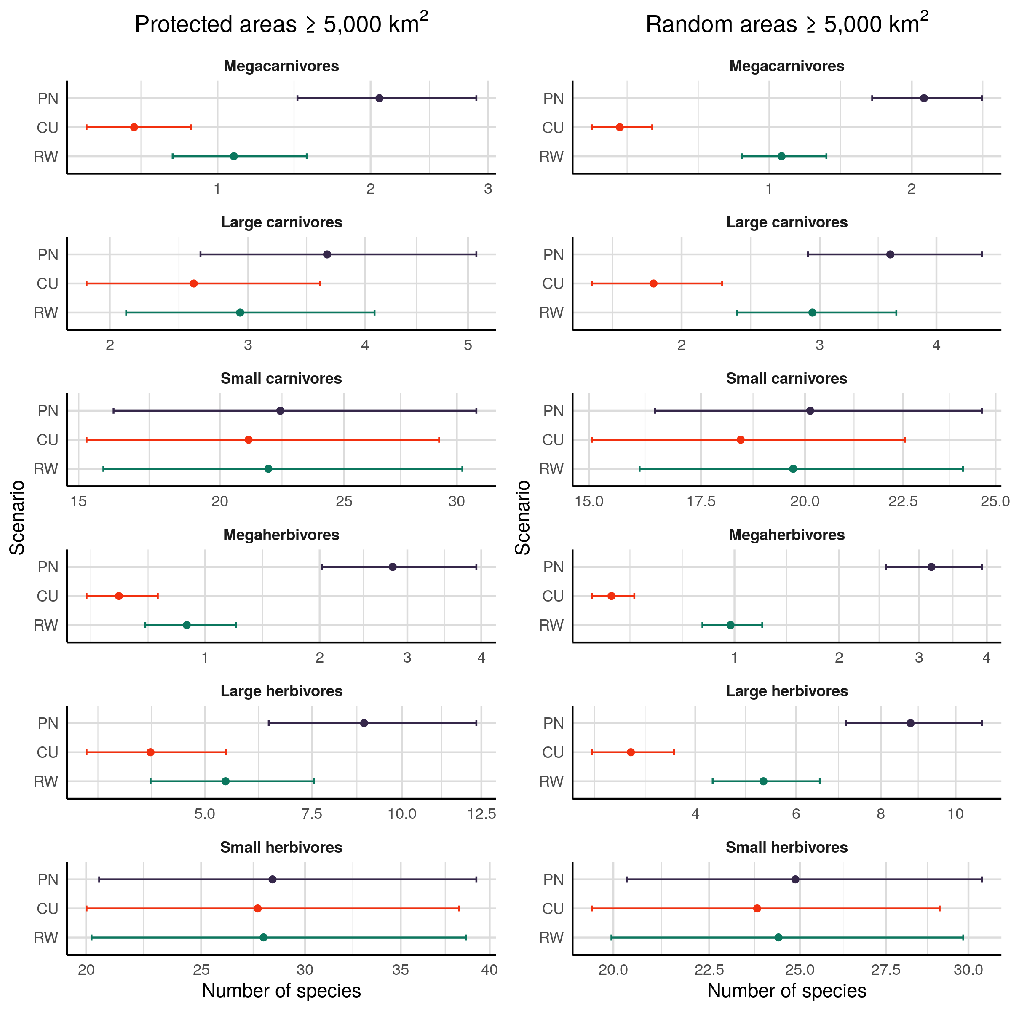

Number of species per trophic level in each scenarios for protected areas $5,000km^{2}$ (left) and for random areas $5,000km^{2}$ (right). In all trophic levels except small herbivores, human driven extinctions and extirpations have significantly reduced the number of species. Rewilding can partly replenish the species pool through reintroduction and introduction of mammals as ecological replacements for globally extinct species, but the number of species in each trophic level cannot be fully restored to natural levels, as many extinct species do not have today functional analogues that are also phylogenetically closely related and therefore cannot be replaced. Notably, rewilding has higher restoration potential outside protected areas, where the impact of human pressure on trophic level species richness has been particularly severe.

In large areas drawn randomly from Ecozones we observed similar but more pronounced patterns. 1) the number of species in all trophic levels but small herbivores and small carnivores significantly decreased from present natural to current conditions, with effect sizes equal or greater than in protected areas. 2) under the rewilding scenario the number of species in all depleted trophic levels were partly replenished to present natural levels, with effect sizes equal or greater than in protected areas. 3) the number of megacarnivores, megaherbivores, large carnivores, and large herbivores was not completely restored to present natural conditions, but this time the magnitude of the differences were comparable to the ones in protected areas. Overall, the effect of Late Pleistocene extinctions and extirpation was higher in random areas than in protected areas. However, the restoration potential of rewilding was also higher in the random areas, and the number of species per trophic level was replenished to similar proportions in protected and random areas.

The number of interactions among trophic levels was affected by extinctions and extirpations of terrestrial mammals in protected areas. All interactions that involved megacarnivores as predators were much lower under current conditions than in the present natural scenario, with very large effect sizes. Also, predator-prey interactions maintained by large carnivores decreased between present natural and current conditions, with a large decrease in the number of predator-prey interactions between large herbivores and large carnivores and small reductions in the number of interactions between small mammals and large carnivores. Notably, the number of interactions between trophic levels that have been affected increased under the rewilding scenario with small to large effect sizes; the only exception was in the number of interactions between large herbivores and large carnivores, that did not increase significantly. Even if rewilding can partly restore the number of interactions, we did not observe a full restoration of trophic interactions to present natural levels, but the interactions were significantly fewer between large herbivores and large carnivores, and between all trophic levels and megacarnivores, with the largest difference in the number of interactions between large carnivores and megacarnivores.

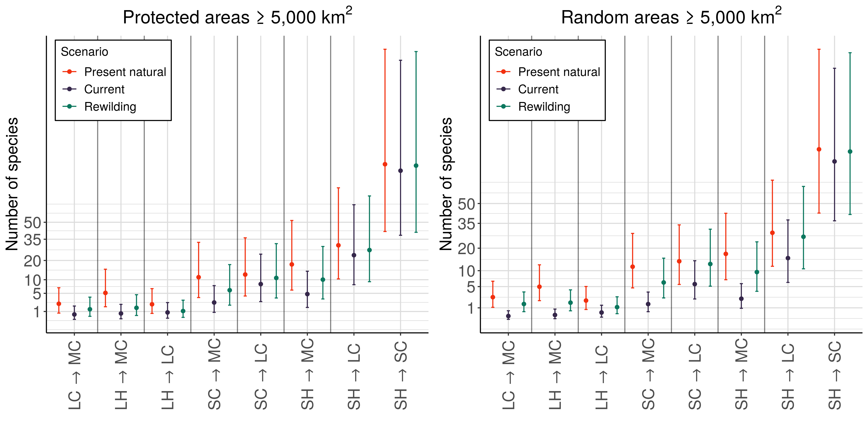

Number of predator-prey interactions between trophic levels in each scenarios for protected areas $5,000km^{2}$ (left) and for random areas $5,000km^{2}$ (right).

In random areas, we observed again similar patterns to protected areas but larger in magnitude. Importantly, the number of interactions between all lower trophic levels and megacarnivores and large carnivores decreased from present natural to current conditions, with medium to very large effect sizes. Also for the number of interactions, the restoration potential of rewilding is higher in random areas, and the higher depletions of trophic interactions can reach be replenished to present natural levels comparable to what observed inside protected areas.

| Trophic level | Present natural - Current | Current - Rewilding | Present natural - Rewilding |
| --- | --- | --- | --- |
|  | **Protected areas** |  |  |
| Megacarnivores ($100kg$) | 1.24 ${}_{verylarge}^{0.00}$ | -0.60 ${}_{medium}^{0.00}$ | 0.64 ${}_{medium}^{0.00}$ |
| Megaherbivores ($1,000kg$) | 1.79 ${}_{verylarge}^{0.00}$ | -0.61 ${}_{medium}^{0.00}$ | 1.18 ${}_{large}^{0.00}$ |
| Large carnivores ($45kg,<100kg$) | 0.35 ${}_{small}^{0.00}$ | -0.13 ${}_{verysmall}^{0.06}$ | 0.22 ${}_{small}^{0.00}$ |
| Large herbivores ($500kg,<1,000kg$) | 0.82 ${}_{large}^{0.00}$ | -0.33 ${}_{small}^{0.00}$ | 0.49 ${}_{small}^{0.00}$ |
| Small carnivores ($45kg$) | 0.06 ${}_{verysmall}^{0.01}$ | -0.04 ${}_{verysmall}^{0.19}$ | 0.02 ${}_{verysmall}^{0.79}$ |
| Small herbivores ($500kg$) | 0.03 ${}_{verysmall}^{0.40}$ | -0.01 ${}_{verysmall}^{1.00}$ | 0.02 ${}_{verysmall}^{1.00}$ |
|  | **Random areas** |  |  |
| Megacarnivores ($100kg$) | 1.89 ${}_{verylarge}^{0.00}$ | -1.21 ${}_{verylarge}^{0.00}$ | 0.67 ${}_{medium}^{0.00}$ |
| Megaherbivores ($1,000kg$) | 2.49 ${}_{huge}^{0.00}$ | -1.31 ${}_{verylarge}^{0.00}$ | 1.19 ${}_{large}^{0.00}$ |
| Large carnivores ($45kg,<100kg$) | 0.68 ${}_{medium}^{0.00}$ | -0.48 ${}_{small}^{0.00}$ | 0.20 ${}_{small}^{0.00}$ |
| Large herbivores ($500kg,<1,000kg$) | 1.10 ${}_{large}^{0.00}$ | -0.59 ${}_{medium}^{0.00}$ | 0.50 ${}_{medium}^{0.00}$ |
| Small carnivores ($45kg$) | 0.09 ${}_{verysmall}^{0.00}$ | -0.07 ${}_{verysmall}^{0.01}$ | 0.02 ${}_{verysmall}^{0.92}$ |
| Small herbivores ($500kg$) | 0.04 ${}_{verysmall}^{0.06}$ | -0.02 ${}_{verysmall}^{0.57}$ | 0.02 ${}_{verysmall}^{0.91}$ |

Table: Differences between regression coefficients estimates of the number of species per trophic level among scenarios. Differences were obtained performing multiple pair-wise contrasts accounting for variation across Ecozones and food webs. Superscripts show the p-value of the contrasts adjusted with the Bonferroni correction and subscripts show the effect size of the change (Cohen's *d* (J. Cohen, 1988; Sawilowsky, 2009)).

| Prey | Predator | Present natural - Current | Current - Rewilding | Present natural - Rewilding |
| --- | --- | --- | --- | --- |
|  |  | **Protected areas** |  |  |
| Large carnivores | Megacarnivores | 1.30 ${}_{verylarge}^{0.00}$ | -0.73 ${}_{medium}^{0.00}$ | 0.56 ${}_{medium}^{0.00}$ |
| Large herbivores | Megacarnivores | 1.92 ${}_{verylarge}^{0.00}$ | -0.74 ${}_{medium}^{0.00}$ | 1.19 ${}_{large}^{0.00}$ |
| Small carnivores | Megacarnivores | 1.45 ${}_{verylarge}^{0.00}$ | -0.84 ${}_{large}^{0.00}$ | 0.62 ${}_{medium}^{0.00}$ |
| Small herbivores | Megacarnivores | 1.31 ${}_{verylarge}^{0.00}$ | -0.74 ${}_{medium}^{0.00}$ | 0.57 ${}_{medium}^{0.00}$ |
| Large herbivores | Large carnivores | 0.93 ${}_{large}^{0.00}$ | -0.19 ${}_{verysmall}^{0.17}$ | 0.74 ${}_{medium}^{0.00}$ |
| Small carnivores | Large carnivores | 0.41 ${}_{small}^{0.00}$ | -0.27 ${}_{small}^{0.00}$ | 0.14 ${}_{verysmall}^{0.07}$ |
| Small herbivores | Large carnivores | 0.26 ${}_{small}^{0.00}$ | -0.14 ${}_{verysmall}^{0.04}$ | 0.12 ${}_{verysmall}^{0.09}$ |
| Small herbivores | Small carnivores | 0.08 ${}_{verysmall}^{0.37}$ | -0.06 ${}_{verysmall}^{0.67}$ | 0.02 ${}_{verysmall}^{1.00}$ |
|  |  | **Random areas** |  |  |
| Large carnivores | Megacarnivores | 2.26 ${}_{huge}^{0.00}$ | -1.70 ${}_{verylarge}^{0.00}$ | 0.56 ${}_{medium}^{0.00}$ |
| Large herbivores | Megacarnivores | 2.67 ${}_{huge}^{0.00}$ | -1.60 ${}_{verylarge}^{0.00}$ | 1.08 ${}_{large}^{0.00}$ |
| Small carnivores | Megacarnivores | 2.05 ${}_{huge}^{0.00}$ | -1.42 ${}_{verylarge}^{0.00}$ | 0.63 ${}_{medium}^{0.00}$ |
| Small herbivores | Megacarnivores | 1.99 ${}_{verylarge}^{0.00}$ | -1.40 ${}_{verylarge}^{0.00}$ | 0.59 ${}_{medium}^{0.00}$ |
| Large herbivores | Large carnivores | 1.34 ${}_{verylarge}^{0.00}$ | -0.72 ${}_{medium}^{0.00}$ | 0.63 ${}_{medium}^{0.00}$ |
| Small carnivores | Large carnivores | 0.89 ${}_{large}^{0.00}$ | -0.80 ${}_{large}^{0.00}$ | 0.09 ${}_{verysmall}^{0.56}$ |
| Small herbivores | Large carnivores | 0.64 ${}_{medium}^{0.00}$ | -0.55 ${}_{medium}^{0.00}$ | 0.09 ${}_{verysmall}^{0.51}$ |
| Small herbivores | Small carnivores | 0.14 ${}_{verysmall}^{0.05}$ | -0.12 ${}_{verysmall}^{0.15}$ | 0.03 ${}_{verysmall}^{1.00}$ |

Table: Differences between regression coefficients estimates of the number of predator-prey interactions between trophic levels among scenarios. Differences were obtained performing multiple pair-wise contrasts accounting for variation across Ecozones and food webs. Superscripts show the p-value of the contrasts adjusted with the Bonferroni correction and subscripts show the effect size of the change (Cohen's *d* (J. Cohen, 1988; Sawilowsky, 2009)).

**Ecozones differences paragraph here and not in discussion.**

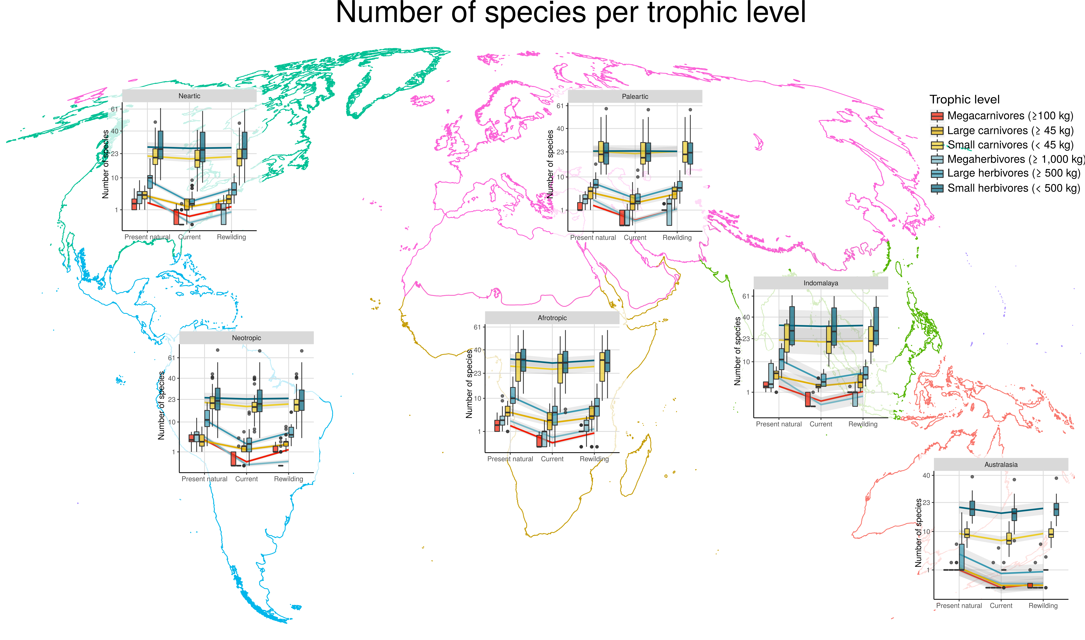

Number of species per trophic level in each Ecozone under the three scenarios studied. MC - megacarnivores ($100kg$); MH - megaherbivores ($1,000kg$); LC - large carnivores ($100kg,≥45kg$); LH - large herbivores ($1,000kg,≥500kg$); SC - small carnivores ($45kg$); SH - small herbivores ($500kg$).

# Discussion

1. General recap of questions and main results
2. Extinctions’ debt only partly balanced by rewilding credit.
3. Difference between Ecozones (qualitatively).
4. Within vs outside protected areas: biodiversity hotspots. Trophic rewilding would be particularly effective outside protected areas.
5. Sociological constraints on rewilding.
6. Less conservative rewilding strategies restore trophic interactions: less strict phylogenetic criteria + de-extinctions.

During the Late Pleistocene, humans have extirpated and caused the extinction of many mammal species, especially of large body-sized megafauna (Martin, 1984; F. A. Smith et al., 2018). This defaunation degraded ecological network by removing predator-prey interactions that shape trophic structure of ecosystems. Trophic rewilding has been proposed as an alternative approach to restore ecosystems to biodiverse, self-sustaining states through species (re)introduction and rewiring of ecological networks (Perino et al., 2019; Svenning et al., 2016). However, rewilding potential to restore ecological networks to pre-human conditions at global scale has not been investigated so far and remained largely unknown. Our results show that rewilding can partly rewire food webs to pre-human conditions, but that a full restoration is not achievable under the examined conservative rewilding scenario that minimized ecological risks and human-wildlife conflicts.

The trophic levels most affected by human pressure were, not surprisingly, that of large sized species. Megacarnivores and megaherbivores severely declined due to past extinctions, followed by large carnivores and large herbivores that had high but relatively smaller decreases in numbers. As a consequence of these species losses, trophic interactions disappeared: interactions maintained by higher trophic levels were pruned away and the top-down control of higher to lower trophic levels decreased. Importantly, as trophic complexity is necessary for self-sustaining biodiverse ecosystems (Perino et al., 2019), the degradation of food webs complexity and community trophic structure likely jeopardize stability and resilience of ecosystems globally (Estes et al., 2011).

Trophic level richness and interactions debts due to past extinctions can partly be balanced by rewilding credit. Reintroduction of species into their present natural ranges together with replacement of globally extinct species with ecological substitutes increased the number of species in affected trophic levels with medium to large effect sizes. Also, we found that trophic interactions among depleted trophic levels partly recovered to pre-human conditions. Overall, our findings highlight the potential of rewilding to partly restore food webs to more natural states. However, a full restoration to pre-human conditions cannot be achieved under the conservative rewilding scenario examined here.

Extinction debt and rewilding credit are higher in random than in protected areas. Human land-use is concentrated in highly productive areas that can potentially host higher biodiversity and species richness (Venter et al., 2018) and the current network of protected areas poorly covers mammalian biodiversity hotspots (Daru et al., 2019). As a consequence, in protected areas current debt is lower because human-drive extinctions have not degraded ecosystems as severely as outside protected areas. Moreover, because in protected areas the potential species richness and complexity of trophic interactions is lower than in random areas, rewilding credit is also lower within protected areas, suggesting that trophic rewilding will be most effective outside the current network of protected areas with strict IUCN management (Ia, Ib, and II). Notably, rewilding deficit is comparable between protected and random areas, showing a similar relative potential of rewilding to restore ecosystems. Overall, these results highlight the importance of rewilding strategies targeting regions outside the protected area network, where (re)introductions of mammals will rewire food webs to pre-human conditions to larger extents and greatly restore ecosystems trophic structure.

Rewilding, especially outside protected areas, will exacerbate human-wildlife conflicts. Society plays an important role in rewilding, as (re)introductions of mammals need to be accepted by governmental and societal agencies to have long-term restoration effects on ecosystems (Perino et al., 2019). Rewilding is likely to cause economic losses to local stakeholders via predation on livestock or damages to crops and pastures. Moreover, people not directly damaged by wildlife can negatively perceive rewilding projects. However, these negative effects of rewilding can be mitigated by the adoption of compensation schemes by governmental agencies (Navarro & Pereira, 2015) and by aligning scientific, managers, and people's conception of nature and rewilding goals (Theunissen, 2019). In this regard, scientific debates about the novelty or the a priori effectiveness of rewilding is sterile. Rather, scientific community and practitioners should look for a common ground for mutual understanding (R. M. Anderson et al., 2019).

In conclusion, our study shows that rewilding can partly restore trophic complexity of ecosystems, but that it cannot rewire food webs completely to pre-human conditions without taking a bolder approach. Here, we simulated a conservative rewilding scenario that minimize risk for native species and maximizes co-existence of reintroduced and introduced mammals. Moreover, only species that were phylogenetically closely related to extinct mammals were considered as rewilding candidates. Focusing only on species' functional role in ecosystems and relaxing the phylogenetic constraint will increase the number of extinct species that can be replaced and can raise the potential of rewilding to rewire food webs. Rewilding, as everything new and bold, will be a controversial topic for the next decades, and implementation and assessment of rewilding projects need further improvements to secure rewilding goals (Root-Bernstein, Gooden, & Boyes, 2018). This does not mean however that rewilding should be ostracized as a failing or unnecessary restoration strategy, but rather that policy makers, societal agencies, managers, and ecologists need to discuss and improve why and how rewilding is implemented. Importantly, new opportunities are opening to implement rewilding at large scales (Ceausu et al., 2015; Chapron et al., 2014); if and how rewilding is adopted will determine whether trophic complexity is restore or not in ecosystems. Our results show that, if the long-term goal is to achieve a self-sustaining biodiverse ecosystems (Perino et al., 2019), rewilding cannot be conservative, but it should be bold and move in directions where more traditional restoration strategies do not dare to go.

# Acknowledgment

We thank the Carlsberg Foundation for economic support of this work through the Semper Ardens project MegaPast2Future (grant CF16-0005 to JCS). JCS also considers this work a contribution to his VILLUM Investigator project 'Biodiversity Dynamics in a Changing World', funded by VILLUM FONDEN (grant 16549).

# Data accessibility

All data was open access. Predator-prey interactions were obtained from the ECOWeB and the GLOBI databases (J. E. Cohen, 2010; Poelen et al., 2014), from two published savanna food webs (Baskerville et al., 2011; Visser et al., 2011). Body mass and species present natural and current distribution ranges were obtained from the PHYLACINE 1.2 database (Faurby et al., 2018). We used climate data from the Worldclim 2.0 database (Fick & Hijmans, 2017) and Ecozone shapefile from the [WWF](https://www.worldwildlife.org/publications/terrestrial-ecoregions-of-the-world) (Olson & Dinerstein, 2002).

# Author contribution

All authors developed the concept and the study design and contributed to the manuscript. EB conceived the idea, performed the analyses, and prepared the manuscript for submission.

# Competing interests

The authors declare no competing interests.

# References

Alston, J., Maitland, B., Brito, B., Esmaeili, S., Ford, A., Hays, B., … Goheen, J. (2019). Reciprocity in restoration ecology: When might large carnivore reintroduction restore ecosystems? *Biological Conservation*, *234*, 82–89.

Anderson, R. M., Buitenwerf, R., Driessen, C., Genes, L., Lorimer, J., & Svenning, J.-C. (2019). Introducing rewilding to restoration to expand the conservation effort: A response to hayward et al. *Biodiversity and Conservation*, *28*(13), 3691–3693.

Atkins, J. L., Long, R. A., Pansu, J., Daskin, J. H., Potter, A. B., Stalmans, M. E., … Pringle, R. M. (2019). Cascading impacts of large-carnivore extirpation in an african ecosystem. *Science*, eaau3561.

Barnosky, A. D. (2008). Megafauna biomass tradeoff as a driver of quaternary and future extinctions. *Proceedings of the National Academy of Sciences*, *105*(Supplement 1), 11543–11548.

Baskerville, E. B., Dobson, A. P., Bedford, T., Allesina, S., Anderson, T. M., & Pascual, M. (2011). Spatial guilds in the serengeti food web revealed by a bayesian group model. *PLoS Computational Biology*, *7*(12), e1002321.

Beschta, R. L., & Ripple, W. J. (2016). Riparian vegetation recovery in yellowstone: The first two decades after wolf reintroduction. *Biological Conservation*, *198*, 93–103.

Carbone, C., Mace, G. M., Roberts, S. C., & Macdonald, D. W. (1999). Energetic constraints on the diet of terrestrial carnivores. *Nature*, *402*(6759), 286.

Ceausu, S., Hofmann, M., Navarro, L. M., Carver, S., Verburg, P. H., & Pereira, H. M. (2015). Mapping opportunities and challenges for rewilding in europe. *Conservation Biology*, *29*(4), 1017–1027.

Ceballos, G., Ehrlich, P. R., Barnosky, A. D., García, A., Pringle, R. M., & Palmer, T. M. (2015). Accelerated modern human–induced species losses: Entering the sixth mass extinction. *Science Advances*, *1*(5), e1400253.

Chapron, G., Kaczensky, P., Linnell, J. D., Arx, M. von, Huber, D., Andrén, H., … others. (2014). Recovery of large carnivores in europe’s modern human-dominated landscapes. *Science*, *346*(6216), 1517–1519.

Chundawat, R. S., Sharma, K., Gogate, N., Malik, P. K., & Vanak, A. T. (2016). Size matters: Scale mismatch between space use patterns of tigers and protected area size in a tropical dry forest. *Biological Conservation*, *197*, 146–153.

Cohen, J. (1988). *Statistical power analysis for the behavioural sciences*. Hillsdale, NJ: erlbaum.

Cohen, J. E. (2010). *ECOWeB 1.1: Ecologists’ cooperative web bank*.

Corporation, M., & Weston, S. (2018). *DoParallel: Foreach parallel adaptor for the ’parallel’ package*. Retrieved from <https://CRAN.R-project.org/package=doParallel>

Daru, B. H., Roux, P. C. le, Gopalraj, J., Park, D. S., Holt, B. G., & Greve, M. (2019). Spatial overlaps between the global protected areas network and terrestrial hotspots of evolutionary diversity. *Global Ecology and Biogeography*, *28*(6), 757–766.

Deinet, S., Ieronymidou, C., McRae, L., Burfield, I. J., Foppen, R. P., Collen, B., … others. (2017). *Wildlife comeback in europe: The recovery of selected mammal and bird species*.

Dirzo, R., Young, H. S., Galetti, M., Ceballos, G., Isaac, N. J., & Collen, B. (2014). Defaunation in the anthropocene. *Science*, *345*(6195), 401–406.

Donlan, J. (2005). Re-wilding north america. *Nature*, *436*(7053), 913.

Eklöf, A., Helmus, M. R., Moore, M., & Allesina, S. (2011). Relevance of evolutionary history for food web structure. *Proceedings of the Royal Society B: Biological Sciences*, *279*(1733), 1588–1596.

Elith, J., & Leathwick, J. R. (2009). Species distribution models: Ecological explanation and prediction across space and time. *Annual Review of Ecology, Evolution, and Systematics*, *40*, 677–697.

Elith, J., Phillips, S. J., Hastie, T., Dudík, M., Chee, Y. E., & Yates, C. J. (2011). A statistical explanation of maxent for ecologists. *Diversity and Distributions*, *17*(1), 43–57.

Emer, C., Galetti, M., Pizo, M. A., Jordano, P., & Verdú, M. (2019). Defaunation precipitates the extinction of evolutionarily distinct interactions in the anthropocene. *Science Advances*, *5*(6), eaav6699.

Estes, J. A., Terborgh, J., Brashares, J. S., Power, M. E., Berger, J., Bond, W. J., … others. (2011). Trophic downgrading of planet earth. *Science*, *333*(6040), 301–306.

Faurby, S., & Svenning, J.-C. (2015). Historic and prehistoric human-driven extinctions have reshaped global mammal diversity patterns. *Diversity and Distributions*, *21*(10), 1155–1166.

Faurby, S., Davis, M., Pedersen, R. Ø., Schowanek, S. D., Antonelli, A., & Svenning, J.-C. (2018). PHYLACINE 1.2: The phylogenetic atlas of mammal macroecology. *Ecology*, *99*(11), 2626–2626. <https://doi.org/10.1002/ecy.2443>

Fick, S. E., & Hijmans, R. J. (2017). WorldClim 2: New 1-km spatial resolution climate surfaces for global land areas. *International Journal of Climatology*, *37*(12), 4302–4315.

Fielding, A. H., & Bell, J. F. (1997). A review of methods for the assessment of prediction errors in conservation presence/absence models. *Environmental Conservation*, *24*(1), 38–49.

Ford, A. T., Goheen, J. R., Otieno, T. O., Bidner, L., Isbell, L. A., Palmer, T. M., … Pringle, R. M. (2014). Large carnivores make savanna tree communities less thorny. *Science*, *346*(6207), 346–349.

Genes, L., Cid, B., Fernandez, F. A., & Pires, A. S. (2017). Credit of ecological interactions: A new conceptual framework to support conservation in a defaunated world. *Ecology and Evolution*, *7*(6), 1892–1897.

Gill, J. L. (2014). Ecological impacts of the late quaternary megaherbivore extinctions. *New Phytologist*, *201*(4), 1163–1169.

Gravel, D., Poisot, T., Albouy, C., Velez, L., & Mouillot, D. (2013). Inferring food web structure from predator–prey body size relationships. *Methods in Ecology and Evolution*, *4*(11), 1083–1090.

Gray, C., Figueroa, D. H., Hudson, L. N., Ma, A., Perkins, D., & Woodward, G. (2015). Joining the dots: An automated method for constructing food webs from compendia of published interactions. *Food Webs*, *5*, 11–20.

Guevara, L., Gerstner, B. E., Kass, J. M., & Anderson, R. P. (2018). Toward ecologically realistic predictions of species distributions: A cross-time example from tropical montane cloud forests. *Global Change Biology*, *24*(4), 1511–1522.

Hayward, M. W., Scanlon, R. J., Callen, A., Howell, L. G., Klop-Toker, K. L., Di Blanco, Y., … others. (2019). Reintroducing rewilding to restoration–Rejecting the search for novelty. *Biological Conservation*, *233*, 255–259.

Hijmans, R. J. (2019). *Raster: Geographic data analysis and modeling*. Retrieved from <https://CRAN.R-project.org/package=raster>

Hijmans, R. J., Phillips, S., Leathwick, J., & Elith, J. (2017). *Dismo: Species distribution modeling*. Retrieved from <https://CRAN.R-project.org/package=dismo>

Hirzel, A. H., Le Lay, G., Helfer, V., Randin, C., & Guisan, A. (2006). Evaluating the ability of habitat suitability models to predict species presences. *Ecological Modelling*, *199*(2), 142–152.

Hof, C., Voskamp, A., Biber, M. F., Böhning-Gaese, K., Engelhardt, E. K., Niamir, A., … Hickler, T. (2018). Bioenergy cropland expansion may offset positive effects of climate change mitigation for global vertebrate diversity. *Proceedings of the National Academy of Sciences*, *115*(52), 13294–13299.

IUCN. (2016). *The iucn red list of threatened species, version 2016-3*. International Union for Conservation of Nature; Natural Resources Cambridge.

Janzen, D. H., & Martin, P. S. (1982). Neotropical anachronisms: The fruits the gomphotheres ate. *Science*, *215*(4528), 19–27.

Jetz, W., Thomas, G. H., Joy, J. B., Redding, D. W., Hartmann, K., & Mooers, A. O. (2014). Global distribution and conservation of evolutionary distinctness in birds. *Current Biology*, *24*(9), 919–930.

Jones, K. R., Venter, O., Fuller, R. A., Allan, J. R., Maxwell, S. L., Negret, P. J., & Watson, J. E. (2018). One-third of global protected land is under intense human pressure. *Science*, *360*(6390), 788–791.

Josh Donlan, C., Berger, J., Bock, C. E., Bock, J. H., Burney, D. A., Estes, J. A., … others. (2006). Pleistocene rewilding: An optimistic agenda for twenty-first century conservation. *The American Naturalist*, *168*(5), 660–681.

Laundré, J. W., Hernández, L., & Ripple, W. J. (2010). The landscape of fear: Ecological implications of being afraid. *Open Ecology Journal*, *3*, 1–7.

Le Roux, E., Kerley, G. I., & Cromsigt, J. P. (2018). Megaherbivores modify trophic cascades triggered by fear of predation in an african savanna ecosystem. *Current Biology*, *28*(15), 2493–2499.

Lenth, R. (2019). *Emmeans: Estimated marginal means, aka least-squares means*. Retrieved from <https://CRAN.R-project.org/package=emmeans>

Linnell, J. D., & Strand, O. (2000). Interference interactions, co-existence and conservation of mammalian carnivores. *Diversity and Distributions*, *6*(4), 169–176.

Liu, C., Newell, G., & White, M. (2016). On the selection of thresholds for predicting species occurrence with presence-only data. *Ecology and Evolution*, *6*(1), 337–348.

Lundgren, E. J., Ramp, D., Ripple, W. J., & Wallach, A. D. (2018). Introduced megafauna are rewilding the anthropocene. *Ecography*, *41*(6), 857–866.

Lüdecke, D., Makowski, D., & Waggoner, P. (2019). *Performance: Assessment of regression models performance*. Retrieved from <https://CRAN.R-project.org/package=performance>

Makowski, D., & Lüdecke, D. (2019). *Estimate: Estimate effects, contrasts and means*. Retrieved from <https://github.com/easystats/estimate>

Malhi, Y., Doughty, C. E., Galetti, M., Smith, F. A., Svenning, J.-C., & Terborgh, J. W. (2016). Megafauna and ecosystem function from the pleistocene to the anthropocene. *Proceedings of the National Academy of Sciences*, *113*(4), 838–846.

Marjakangas, E.-L., Genes, L., Pires, M. M., Fernandez, F. A., Lima, R. A. de, Oliveira, A. A. de, … Galetti, M. (2018). Estimating interaction credit for trophic rewilding in tropical forests. *Philosophical Transactions of the Royal Society B: Biological Sciences*, *373*(1761), 20170435.

Martin, P. S. (1984). Prehistoric overkill: The global model. *Quaternary Extinctions: A Prehistoric Revolution*, 354–403.

Merow, C., Smith, M. J., & Silander Jr, J. A. (2013). A practical guide to maxent for modeling species’ distributions: What it does, and why inputs and settings matter. *Ecography*, *36*(10), 1058–1069.

Merow, C., Smith, M. J., Edwards Jr, T. C., Guisan, A., McMahon, S. M., Normand, S., … Elith, J. (2014). What do we gain from simplicity versus complexity in species distribution models? *Ecography*, *37*(12), 1267–1281.

Microsoft, & Weston, S. (2017). *Foreach: Provides foreach looping construct for r*. Retrieved from <https://CRAN.R-project.org/package=foreach>

Navarro, L. M., & Pereira, H. M. (2015). Rewilding abandoned landscapes in europe. In *Rewilding european landscapes* (pp. 3–23). Springer, Cham.

Nogués-Bravo, D., Simberloff, D., Rahbek, C., & Sanders, N. J. (2016). Rewilding is the new pandora’s box in conservation. *Current Biology*, *26*(3), R87–R91.

Olson, D. M., & Dinerstein, E. (2002). The global 200: Priority ecoregions for global conservation. *Annals of the Missouri Botanical Garden*, 199–224.

Olson, D. M., Dinerstein, E., Wikramanayake, E. D., Burgess, N. D., Powell, G. V., Underwood, E. C., … others. (2001). Terrestrial ecoregions of the world: A new map of life on eartha new global map of terrestrial ecoregions provides an innovative tool for conserving biodiversity. *BioScience*, *51*(11), 933–938.

Owen-Smith, N. (1987). Pleistocene extinctions: The pivotal role of megaherbivores. *Paleobiology*, *13*(3), 351–362.

Owen-Smith, N., & Mills, M. G. (2008). Predator–prey size relationships in an african large-mammal food web. *Journal of Animal Ecology*, *77*(1), 173–183.

O’brien, R. M. (2007). A caution regarding rules of thumb for variance inflation factors. *Quality & Quantity*, *41*(5), 673–690.

Pebesma, E. (2018). Simple Features for R: Standardized Support for Spatial Vector Data. *The R Journal*, *10*(1), 439–446. <https://doi.org/10.32614/RJ-2018-009>

Perino, A., Pereira, H. M., Navarro, L. M., Fernández, N., Bullock, J. M., Ceaușu, S., … others. (2019). Rewilding complex ecosystems. *Science*, *364*(6438), eaav5570.

Phillips, S. (2017). *Maxnet: Fitting ’maxent’ species distribution models with ’glmnet’*. Retrieved from <https://CRAN.R-project.org/package=maxnet>

Phillips, S. J., Anderson, R. P., Dudík, M., Schapire, R. E., & Blair, M. E. (2017). Opening the black box: An open-source release of maxent. *Ecography*, *40*(7), 887–893.

Pires, M. M. (2017). Rewilding ecological communities and rewiring ecological networks. *Perspectives in Ecology and Conservation*, *15*(4), 257–265.

Pires, M. M., Koch, P. L., Farina, R. A., Aguiar, M. A. de, Reis, S. F. dos, & Guimarães Jr, P. R. (2015). Pleistocene megafaunal interaction networks became more vulnerable after human arrival. *Proceedings of the Royal Society B: Biological Sciences*, *282*(1814), 20151367.

Poelen, J. H., Simons, J. D., & Mungall, C. J. (2014). Global biotic interactions: An open infrastructure to share and analyze species-interaction datasets. *Ecological Informatics*, *24*, 148–159.

Pomeranz, J. P., Thompson, R. M., Poisot, T., & Harding, J. S. (2019). Inferring predator–prey interactions in food webs. *Methods in Ecology and Evolution*, *10*(3), 356–367.

Poo-Muñoz, D. A., Escobar, L. E., Peterson, A. T., Astorga, F., Organ, J. F., & Medina-Vogel, G. (2014). Galictis cuja (mammalia): An update of current knowledge and geographic distribution. *Iheringia. Série Zoologia*, *104*(3), 341–346.

R Core Team. (2018). *R: A language and environment for statistical computing*. Retrieved from <https://www.R-project.org/>

Ripple, W. J., Estes, J. A., Beschta, R. L., Wilmers, C. C., Ritchie, E. G., Hebblewhite, M., … others. (2014). Status and ecological effects of the world’s largest carnivores. *Science*, *343*(6167), 1241484.

Robinson, N., Regetz, J., & Guralnick, R. P. (2014). EarthEnv-dem90: A nearly-global, void-free, multi-scale smoothed, 90m digital elevation model from fused aster and srtm data. *ISPRS Journal of Photogrammetry and Remote Sensing*, *87*, 57–67.

Root-Bernstein, M., Gooden, J., & Boyes, A. (2018). Rewilding in practice: Projects and policy. *Geoforum*, *97*, 292–304.

Runge, C. A., Watson, J. E., Butchart, S. H., Hanson, J. O., Possingham, H. P., & Fuller, R. A. (2015). Protected areas and global conservation of migratory birds. *Science*, *350*(6265), 1255–1258.

Sandom, C., Faurby, S., Sandel, B., & Svenning, J.-C. (2014). Global late quaternary megafauna extinctions linked to humans, not climate change. *Proceedings of the Royal Society B: Biological Sciences*, *281*(1787), 20133254.

Sawilowsky, S. S. (2009). New effect size rules of thumb. *Journal of Modern Applied Statistical Methods*, *8*(2), 597–599.

Segura, A. M., Farina, R. A., & Arim, M. (2016). Exceptional body sizes but typical trophic structure in a pleistocene food web. *Biology Letters*, *12*(5), 20160228.

Smith, F. A., Smith, R. E. E., Lyons, S. K., & Payne, J. L. (2018). Body size downgrading of mammals over the late quaternary. *Science*, *360*(6386), 310–313.

Svenning, J.-C., Pedersen, P. B., Donlan, C. J., Ejrnæs, R., Faurby, S., Galetti, M., … others. (2016). Science for a wilder anthropocene: Synthesis and future directions for trophic rewilding research. *Proceedings of the National Academy of Sciences*, *113*(4), 898–906.

Swets, J. A. (1988). Measuring the accuracy of diagnostic systems. *Science*, *240*(4857), 1285–1293.

Tanentzap, A. J., & Smith, B. R. (2018). Unintentional rewilding: Lessons for trophic rewilding from other forms of species introductions. *Philosophical Transactions of the Royal Society B: Biological Sciences*, *373*(1761), 20170445.

Theunissen, B. (2019). The oostvaardersplassen fiasco. *Isis*, *110*(2), 341–345.

UNEP-WCMC, & IUCN. (2019). *Protected planet: The world database on protected areas (wdpa)*. Retrieved from www.protectedplanet.net

Valiente-Banuet, A., Aizen, M. A., Alcántara, J. M., Arroyo, J., Cocucci, A., Galetti, M., … others. (2015). Beyond species loss: The extinction of ecological interactions in a changing world. *Functional Ecology*, *29*(3), 299–307.

Venter, O., Magrach, A., Outram, N., Klein, C. J., Possingham, H. P., Di Marco, M., & Watson, J. E. (2018). Bias in protected-area location and its effects on long-term aspirations of biodiversity conventions. *Conservation Biology*, *32*(1), 127–134.

Visser, S. N. de, Freymann, B. P., & Olff, H. (2011). The serengeti food web: Empirical quantification and analysis of topological changes under increasing human impact. *Journal of Animal Ecology*, *80*(2), 484–494.

Wickham, H. (2016). *Ggplot2: Elegant graphics for data analysis*. Retrieved from [https://ggplot2.tidyverse.org](https://ggplot2.tidyverse.org/)

Wickham, H. (2017). The tidyverse. *R Package Ver. 1.1. 1*.

Williams, R. J., & Martinez, N. D. (2000). Simple rules yield complex food webs. *Nature*, *404*(6774), 180.

Woodroffe, R., & Ginsberg, J. R. (1998). Edge effects and the extinction of populations inside protected areas. *Science*, *280*(5372), 2126–2128.

Yeakel, J. D., Pires, M. M., Rudolf, L., Dominy, N. J., Koch, P. L., Guimarães, P. R., & Gross, T. (2014). Collapse of an ecological network in ancient egypt. *Proceedings of the National Academy of Sciences*, *111*(40), 14472–14477.

Zuur, A., Ieno, E. N., Walker, N., Saveliev, A. A., & Smith, G. M. (2009). *Mixed effects models and extensions in ecology with r*. Springer Science & Business Media.